


PRESS RELEASE Prague, 18th October 2017

Pavilion building being built in BB Centrum for Elijáš Christian School

The Elijáš Christian Primary and Nursery school, which is part of the multifunctional
BB Centrum complex in Prague 4, will be expanding to include a high school from 1 September 2018. In connection with this project, the carcase of a pavilion with a useful area of around 1000 m2 has currently been completed across from the school building. This will be used for the students’ dining and leisure activities, thereby freeing up capacity in the existing primary school for establishing another level of education. The investor in the construction of the pavilion is the non-profit organisation Maranatha z.s., and the construction is being done
by Porr a.s. The expenses for the construction will reach 35 million crowns.

The pavilion building has a useful area of around 1000 m2 and is surrounded by 619 m2 of greenery and supplementary elements such as pavements, terraces, etc. Students and staff will have a dining room and the related cooking facilities, activity rooms and staff facilities, change rooms and sanitary facilities in the new building.

There are currently 206 students attending the primary school and 40 children attending the nursery school and the expenses for their operations since they were founded, i.e. from 2008, has exceeded 175 million crowns. The pavilion will be opening at the beginning of the new school year, i.e. from
3 September 2018, together with the launch of the new high school. Now, since 1 September 2017,
it bears the name Elijáš Christian High School, Primary School and Nursery School.

The founder of the school is the non-profit organisation Maranatha, which was established in 2002
by Radim Passer, the developer of BB Centrum, and which is currently celebrating the 15th anniversary of its establishment. With this project it is supporting the organisation of the education
of children and youth on a Christian basis and a healthy lifestyle. The educational authority is the Czech association of the Seventh-day Adventist Church.

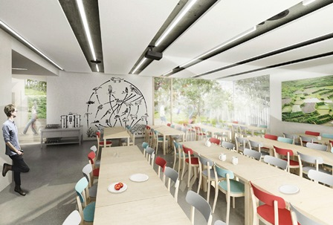

Elijáš Christian High School, Primary School and Nursery School – visualisation of school dining room

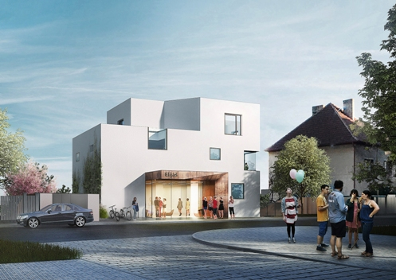

Elijáš Christian High School, Primary School and Nursery School – visualisation of school pavilion

For more information and photographs in print quality please contact:

Kristýna Samková, Head of PR and Marketing dept.
PASSERINVEST GROUP, a.s.
Tel.: (+420) 221 582 111
Mobil: (+420) 602 186 708
E-mail: Kristyna.Samkova@Passerinvest.cz
www.passerinvest.cz, www.bbcentrum.cz

Marcela Štefcová
Crest Communications a.s.
Mobile: (+420) 731 613 669
E-mail: marcela.stefcova@crestcom.cz
www.crestcom.cz

INFORMATION FOR EDITORS

Maranatha was founded as a Christian-oriented organisation in 2002 by Radim Passer and its mission is to spread the hope of a fulfilling life, better relationships and a healthier lifestyle through faith in Jesus Christ. It offers a wide palette of activities from a vegetarian restaurant and health-food shop to aid projects for victims of natural catastrophes. The basic values and missions include the support of the spiritual, mental, social and physical development of man, a natural lifestyle, a quality way of life and upbringing together with a lifelong education in the spirit of Christian principles. The main headquarters are in BB Centrum in Prague’s Michle district. You can find further information at www.maranatha.cz

ABOUT THE DEVELOPER

PASSERINVEST GROUP, a. s., is a purely Czech development company, whose name is primarily connected with the construction of the multifunctional BB Centrum complex in Prague 4 – Michle. The company, founded in 1991 by Radim Passer, built a very good name on both a domestic and international level with this, the most successful and extensive Czech project of its kind. This is not only due to the quality of the implemented projects and the high level of provided services, but also to a sense of fair play, an accommodating relationship with the tenants/users of the buildings and the responsibility towards society and the environment. PASSERINVEST GROUP also has other interesting development projects in its portfolio.

